**Anime Club Schedule**



Sept 28

Oct 12

Oct 26

Nov 2

Nov 30

Dec 14

Jan 11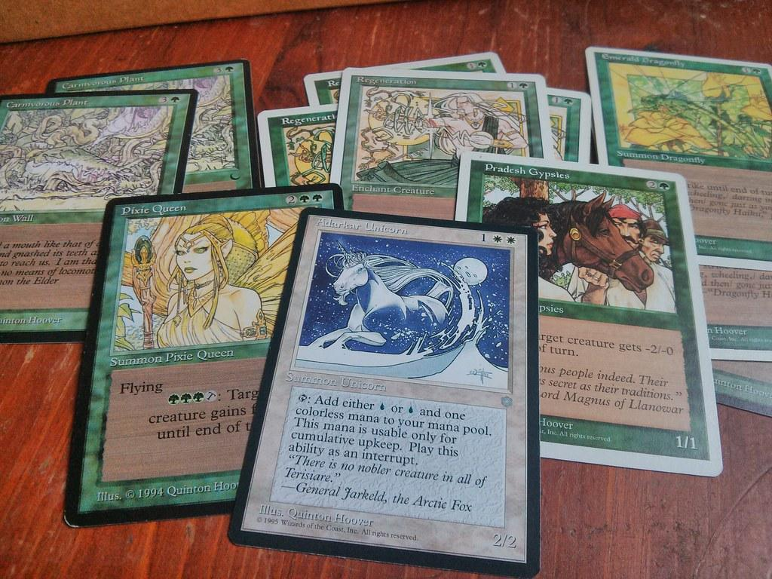

Jan 25

Feb 8

Feb 22

Mar 15

Mar 29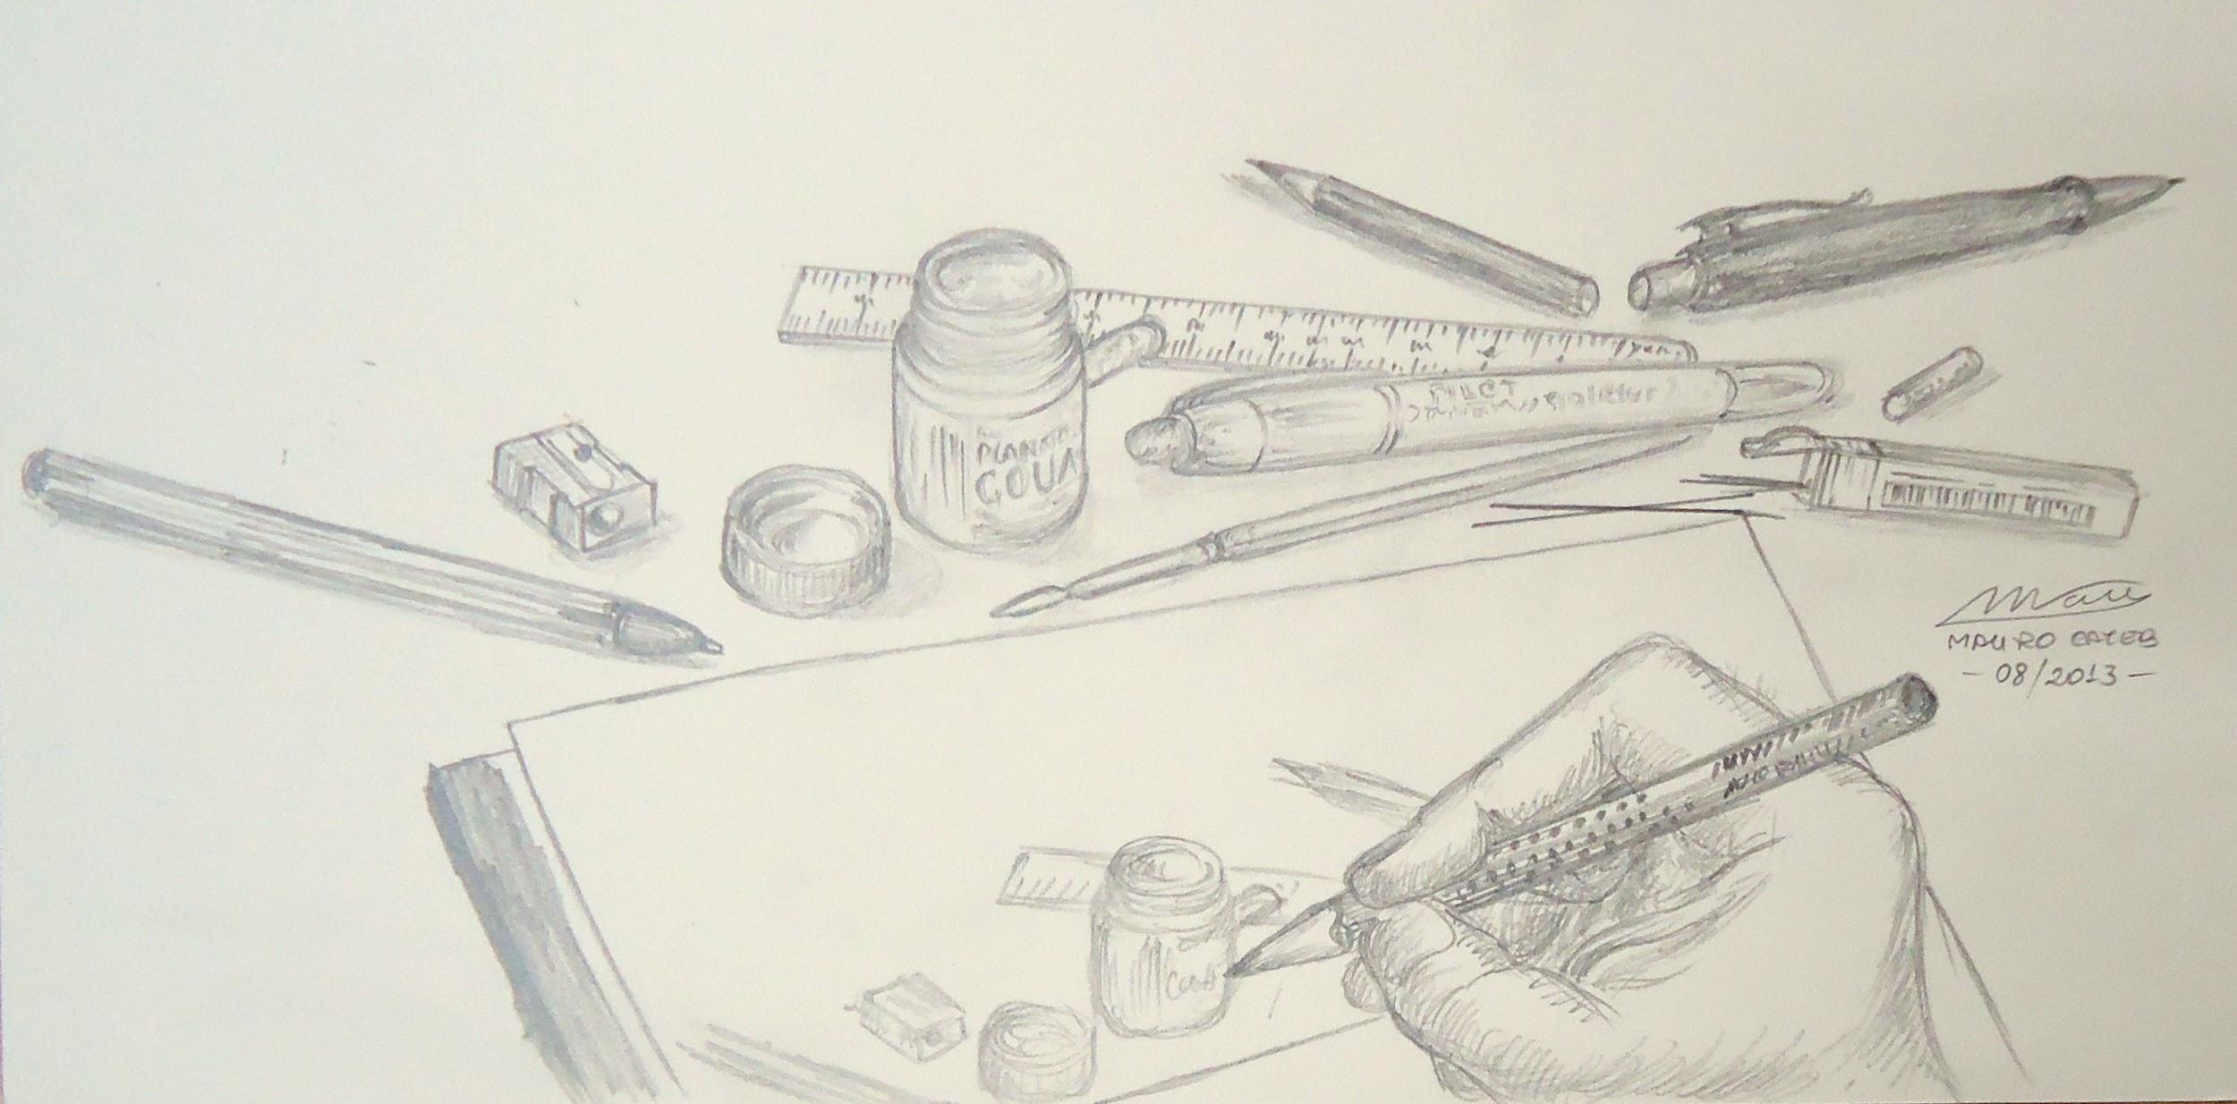

Apr 12

Apr 26

May 17

May 24

In the cafeteria until 5 pm